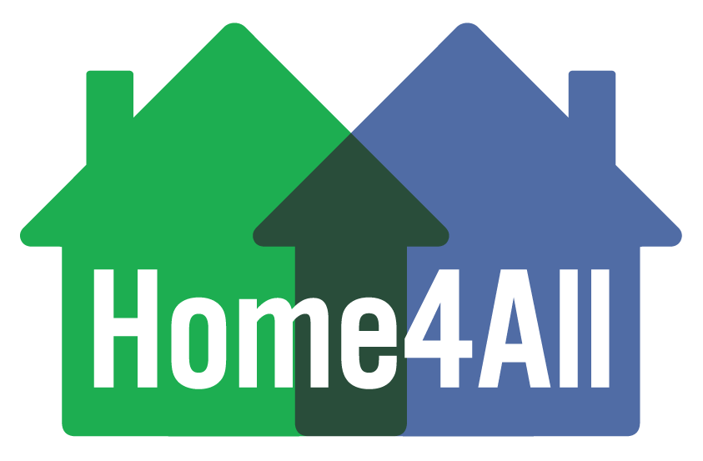

**HOME4ALL CHECKLIST  
Forms in blue are MHC required forms.**

**E-Signatures are acceptable on all the forms except the Mortgage Note & Deed of Trust**

**Mortgagor: HOME4ALL Reservation Number:**

**HOUSING COUNSELOR CLIENT INTAKE PACKAGE**

* Copy of most recent 2 years completed signed Federal Tax Return Form 1040 Tax Return for ALL household members
* Copy of Social Security card(s) or Copy of Alien Registration card(s)
* Copy of Driver’s license(s), State I.D., or Birth Certificate(s)
* Verification of Employment(s) and most recent pay stub(s). If Self-employed two most recent complete Federal Tax returns.
* Most recent two (2) months bank statements on all bank accounts (including IRA’s, Stocks, etc.). If assets exceed $5,000 – a copy of the previous 6 mos. Bank statements are required.
* Child Support Statement-MUST IINCLUDE SUPPORTING DOCS
* Copy of the Home Buyer’s Education Counseling Certificate for each borrower
* Copy of Credit Report from all borrowers (SOFT PULL)
* MHC Income Calculation Worksheet
* Executed Non-borrower Statement
* Home4All Flow Chart
* Lender Referral Form

**LENDER RESERVATION PACKAGE**

* Reservation Confirmation
* Copy of Executed Sales Contract
* Copy of Executed Loan Application

**LENDER COMPLIANCE PACKAGE**

* FHA Transmittal, Fannie Mae 1008 VA Loan Analysis, or USDA Eligibility Summary
* VOE(s) and most recent pay stub(s). If Self-employed two most recent complete Federal Tax returns.
* MHC Income Calculation Worksheet
* Copy of most recent complete signed Federal Tax Return Form 1040 Tax Return for ALL household members
* Copy of Good Faith Estimate
* Copy of Credit Report
* Executed Non-borrower Statement
* Borrower Certification
* MHC Letter of Explanation
* Copy of the Appraisal (URAR). Must clearly state the property meets HUD Minimum Property Standards
* Attorney Information Form with Wiring Instructions
* Copy of Preliminary HUD-1
* Copy of Certificate of Occupancy (if construction)
* Copy of Certified Home Inspection Report
* Copy of signed Property Inspection Clearance Letter
* Copy of Lead-Based Paint Inspection, if applicable for homes built before 1978
* Copy of Final Home Inspection Report if repairs were required.
* Homebuyer/Grant Agreement
* Notification of Change Form (if applicable)
* MCC Forms (if applicable)

**LENDER PURCHASE CERTIFICATION (PC) PACKAGE UPLOAD ONLINE (Due 30 days post-closing)**

* Executed Borrower Affidavit (if using MCC)
* Copy of the Executed Note
* Copy of the Recorded Deed of Trust
* Copy of Final Executed Closing Disclosures
* Copy of Recorded Recapture Deed Restriction
* Copy of Homeowners Insurance Declarations Page
* Copy of Title Policy